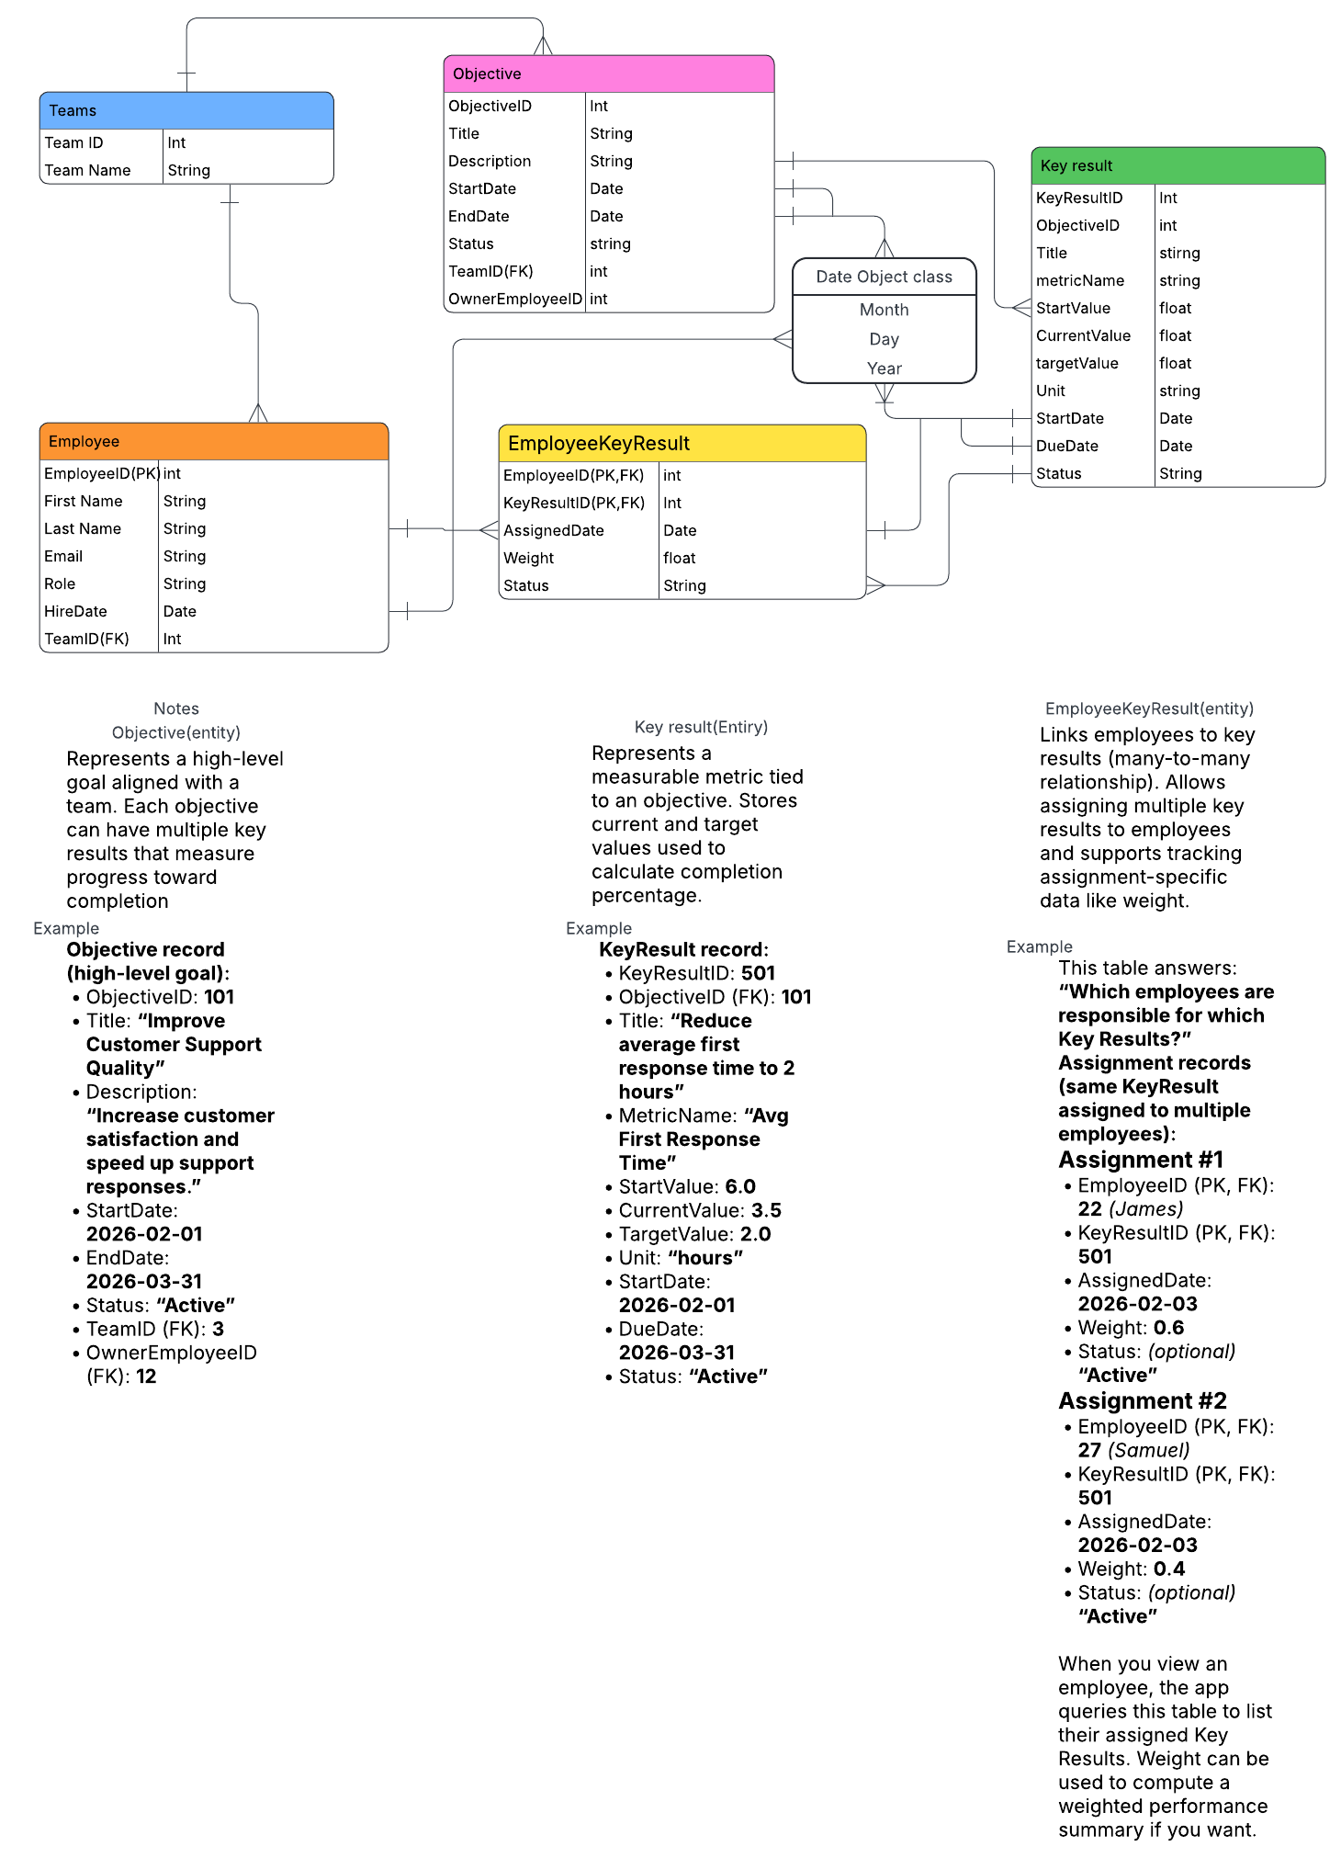
https://github.com/JChrisMarek-edu/SPU_CSC3220_W26_Team_Magenta

